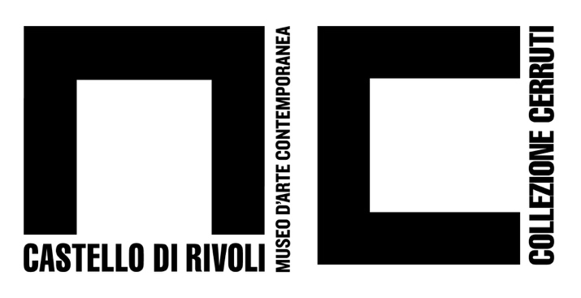
Piazza Mafalda di Savoia - 10098 Rivoli (Torino) - Italia
tel. +39/011.9565222 – 9565280 fax +39/011.9565231
e-mail: info@castellodirivoli.org – www.castellodirivoli.org

PRESS RELEASE

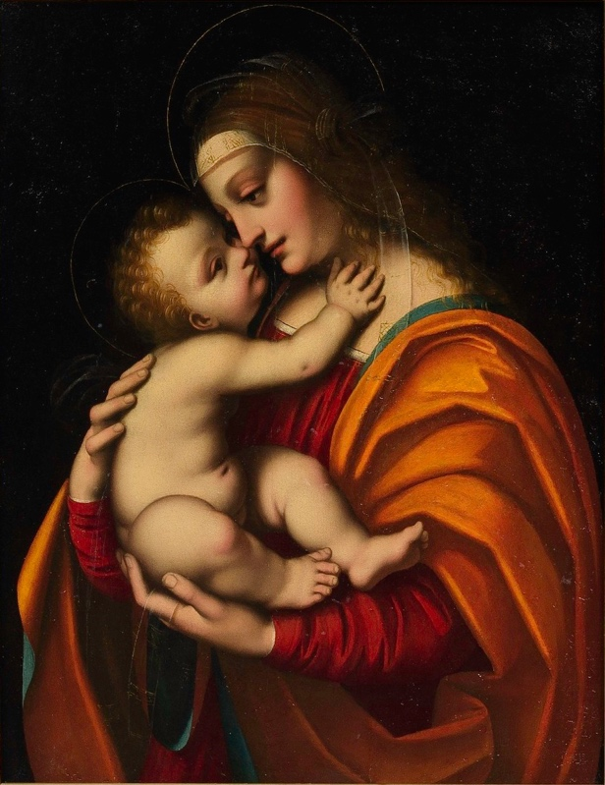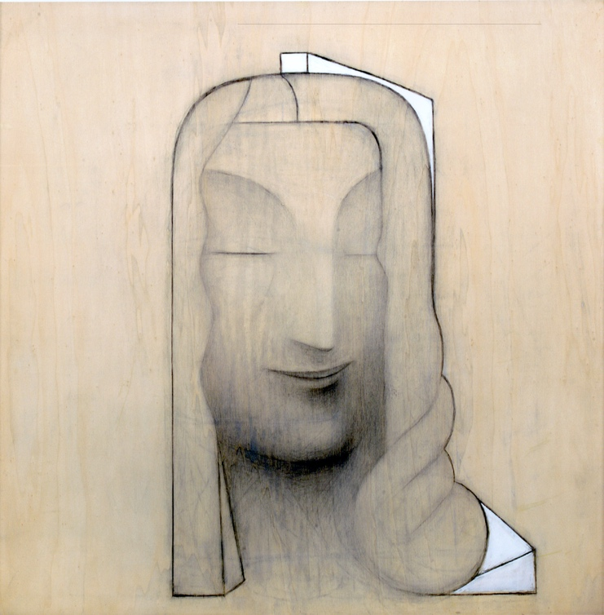

Marco d’Oggiono, Madonna col Bambino (Madonna and Child) 1516 c. Gino De Dominicis, Senza titolo (La Gioconda) Untitled (Gioconda) 1992
Collezione Fondazione Cerruti, long-term loan to Collezione Fondazione Cerruti, long-term loan to
Castello di Rivoli Museum of Contemporary Art, Rivoli-Turin Castello di Rivoli Museum of Contemporary Art, Rivoli-Turin

D’après Leonardo
curated by Laura Cantone and Fabio Cafagna
July 9 – November 3, 2019

On the occasion of the Leonardo da Vinci’s 500th anniversary (1452-1519), Castello di Rivoli Museum of Contemporary Art presents two major artworks from the Cerruti Collection of Castello di Rivoli: Madonna col Bambino (Madonna and Child, 1516 ca.) by Italian Renaissance painter and Leonardo’s chief pupil, Marco d’Oggiono (1475 ca. – 1530 ca.), and Senza titolo - La Gioconda (Untitled – The Mona Lisa, 1992) by Gino De Dominicis (1947-1998).

Drawing from d’Oggiono’s and De Dominicis’ artworks, the exhibition curated by Laura Cantone and Fabio Cafagna – art historians of Cerruti Collection at Castello di Rivoli –, sheds light on Leonardo’s legacy and the uninterrupted fortune of his work. From the lasting influence on his followers to contemporary revivals, Leonardo’s work is undoubtedly an icon to which contemporary artists still refer.
The painting Madonna and Child is an important work by artist Marco d’Oggiono. It depicts the Virgin Mary gently holding Jesus while they gaze at each other in an intimate gesture. The pale flesh tones of the Child and the warm colors of the Virgin’s apparel allow the figures to stand out against the black panel. The artist enriches the sophisticated entanglement of tones – made of the reddish garment and the orange mantle with its aquamarine inner lining – by posing a transparent veil with subtle embroidered-like gleams of gold on the Virgin’s forehead. The overall composition pays homage to the Hermitage Museum’s Madonna Litta (1490 ca.), whose authorship the museum of Saint Petersburg attributes to Leonardo, albeit some Italian scholars attribute it to Giovanni Antonio Boltraffio or Marco d’Oggiono himself, perhaps following an original by Leonardo. Although the Madonna Litta iconography had a huge resonance for d’Oggiono, this painting from the Cerruti Collection, presented in the frame of this exhibition, is the most refined among the existing versions preserved.

The painting Untitled (Mona Lisa) of 1992 is part of a series of large drawings on poplar wood panel begun in the late 1980s by Gino De Dominicis, taking its cue from the enigmatic character of Leonardo’s Mona Lisa. In the late 1980s, the artist moved from early conceptual and performative artistic practice to a latter interest in the understanding of painting and installation. Both in his early and late artistic periods, De Dominicis was reluctant to embracing the phenomenology of embodied experience typical of the artists of his time; rather, he was in favor of exploring a cosmic vision of immortality which could transcend time and space. This a principle the artist perceived in Leonardo’s Mona Lisa. The series presents solemn female figures, whose traits are dissolved into pure archetype: the artist depicts visages of distant beauty and exhausted grace, and their elusive features seem to echo inner world. In this series, De Dominicis creates a line continuity with the past history of art, albeit quite discretionary: from the Picasso’s gigantic figures to Leonardo’s sfumato technique. In the painting presented in this exhibition, the ambivalent expression on Mona Lisa’s three-quarter profile, with her closed eyelids and a half smile, is embedded within a monumental head. Obtained through a thick use of pencil and charcoal, the chiaroscuro is well defined on the chin to then being merely perceptible on the rest of the panel, where the wood grain itself becomes to be expressive.

Madonna and Child by Marco d’Oggiono and Untitled (Mona Lisa) by Gino De Dominicis have been respectively examined by Jacopo Tanzi and Fabio Belloni, whose critical contributions will be featured in the forthcoming comprehensive catalog of the Cerruti Collection, which will be published by Umberto Allemandi Editore in late 2019.

As an additional major event to be confirmed, Director of Castello di Rivoli Museum of Contemporary Art and of the Cerruti Foundation, Carolyn Christov-Bakargiev will contribute to the exhibition by drafting a dialog between the two artworks from Cerruti Collection and a third surprise artwork to be announced shortly. This contribution will stem from her considerations around “the questionable art historical and market assessment of Leonardo’s work in the digital age – pivoting on scientific culture rather than the humanistic, on a rampant informational accelerationism in the digital age, on a difficulty to define provenance and determine authorship of artworks, as well as on a visceral interest in canonical masters of the history of art, Leonardo da Vinci above all.” (Christov-Bakargiev)

Press Office Castello di Rivoli
Manuela Vasco | press@castellodirivoli.org | tel. +39.0119565209

International Press
Sarah Greenberg | sgreenberg@evergreen-arts.com | tel. +44.7866543242

International Communications Advisor for the contemporary art program and commissions at Castello di Rivoli
Henriette Gallus | henriette.gallus@googlemail.com | tel. +43.6764369462

