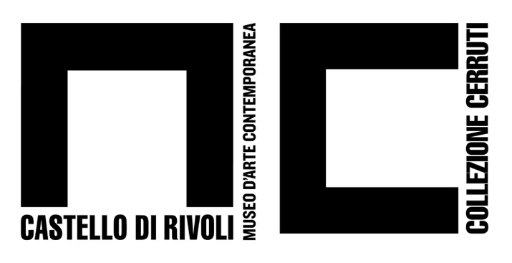
Piazza Mafalda di Savoia - 10098 Rivoli (Torino) - Italia
tel. +39/011.9565222 – 9565280 fax +39/011.9565231
e-mail: info@castellodirivoli.org – www.castellodirivoli.org

PRESS RELEASE

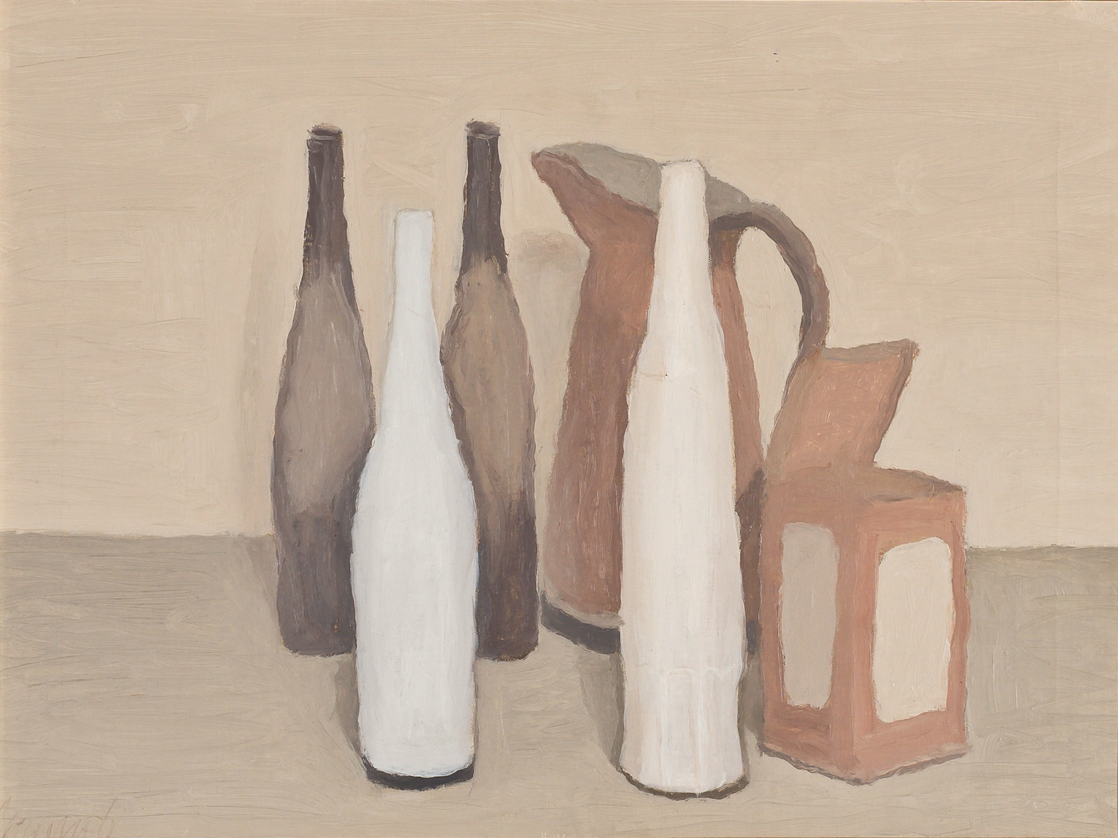
Giorgio Morandi, Natura morta, 1951
Collezione Fondazione Francesco Federico Cerruti per l’Arte, long termo loan
Castello di Rivoli Museo d’Arte Contemporanea, Rivoli-Torino. Photo © Alessandro Fiamingo
© GIORGIO MORANDI, by SIAE 2020

Giorgio Morandi: Major Works from the Cerruti Collection
Curated by Carolyn Christov-Bakargiev, with Fabio Cafagna and Laura Cantone
February 25 – June 28, 2020
Opening: Monday February 24, 2020, 7 pm

With the exhibition Giorgio Morandi: Major Works from the Cerruti Collection the Castello di Rivoli Museum of Contemporary Art continues the in-depth program on the works of the Cerruti Collection. After the exhibitions Giorgio de Chirico: Major Works from the Francesco Federico Cerruti Collection (curated by Carolyn Christov-Bakargiev and Marcella Beccaria, March 6 - November 4, 2018), Andy Warhol: Two Major Works from the Collection of Francesco Federico Cerruti (curated by Fabio Belloni, January 22 – April 22, 2019) and D’après Leonardo (curated by Laura Cantone and Fabio Cafagna, July 8, 2019 – January 5, 2020), Castello di Rivoli will present to the public the core of paintings by Giorgio Morandi (Bologna, 1890-1964) collected by the industrialist Francesco Federico Cerruti (Genoa, 1922 - Turin, 2015) who left his exceptional collection and villa in Rivoli to the museum.

Thanks to an agreement signed in July 2017 with the Francesco Federico Cerruti Foundation, the Castello di Rivoli Museum of Contemporary Art was bequeathed this legendary private collection that includes work from the Middle Ages through the twentieth century, as well as the nearby villa designed to house it, making Castello di Rivoli the first museum of contemporary art in the world to include in its collections an encyclopedic collection from the past. Because of this bequest, Castello di Rivoli aims to create a new model of museum in which the art of different eras is observed from contemporary perspectives, thus making possible a vital comparison between collections, today’s artists and masterpieces from distant historical periods. The Cerruti Collection, the result of the passion and intelligence of Francesco Federico Cerruti, an entrepreneur and collector who passed away after a discreet and reserved life in 2015, at the age of 93, has been the museum’s new center since May 2019. It is a private collection of the highest quality that includes almost three hundred sculptural and pictorial works ranging from the Middle Ages to the contemporary, as well as collection of ancient books, bindings, more than three hundred pieces of furniture and furnishings including carpets and writing desks by famous cabinet makers. In particular, the collection includes works by major artists throughout the ages, from Bernardo Daddi and Pontormo to Renoir, de Chirico, Modigliani, Kandinsky, Klee, Boccioni, Balla, Magritte and Picasso through the second half of the twentieth century, with Bacon, Burri, Warhol, De Dominicis and Paolini.

The five paintings by Giorgio Morandi belonging to the Cerruti Collection testify to the variety of pictorial languages of one of the most significant artists of the twentieth century and thus refute the criticism of monotony, thematic and formal, sometimes levied at the artist, instead allowing us to see his ongoing exploration of still life and reduced palette as a meditation on form and perception. The works from the Cerruti Collection allow us to comprehensively retrace the entire chronological span of Morandi’s artistic experience. In terms of execution, Morandi’s painting evolves from the significantly chiaroscuro style, rich in tonal modulations, of the Natura morta (Still Life) of 1945, to the opaque surfaces of the 1951 version, created with dense and overlapping brush strokes. In terms of visual direction, the blocks of colour in the 1939 Paesaggio (Landscape) seem almost to oppose the soft light modulation, reminiscent of the fifteenth-century painting of Piero della Francesca, of the Fiori (Flowers) of 1954 and the Natura morta (Still Life) of 1958.

“Author of more than 1,300 paintings spanning much of the twentieth century,” says Carolyn Christov-Bakargiev, “the peaceful and enigmatic work of the Bolognese artist Giorgio Morandi is based on the simplification and continuous variation of a few subjects, on the use of a limited palette of shades while the world outside was upset by world wars and socio-political changes. Morandi almost anticipated minimalism in a delicate balance between figurative art and abstraction, tending to the sublime effect of pure visibility. In contrast to the world outside the painter’s studio, characterized by noise and upheaval, Morandi in the studio painted still lives - simple and humble bottles and vases, a world enclosed in the mental space of the exercise of seeing.”

Morandi’s paintings, exhibited in the rooms on the first floor of the Castello di Rivoli, are juxtaposed in dialogue with some of the most significant works of the museum’s collections by artists including Ettore Spalletti (Cappelle sul Tavo, Pescara, 1940 - Spoltore, Pescara, 2019), Michelangelo Pistoletto (Biella, 1933), Alighiero Boetti (Turin, 1940 - Rome, 1994), and Maurizio Cattelan (Padua, 1960), and Emilio Prini (Stresa, 1943 – Rome, 2016), showing the current and uninterrupted relevance of this twentieth-century master.

Giorgio Morandi (Bologna, 1890-1964) after studying at the Academy of Fine Arts in Bologna, in 1914 he began his exhibition career by participating in an exhibition at the hotel Baglioni in Bologna together with Mario Bacchelli, Osvaldo Licini, Severo Pozzati and Giacomo Vespignani, and at the First Free Futurist Exhibition of the Sprovieri Gallery in Rome. Sensitive to the painting of Paul Cézanne and the French Impressionists, he is at the same time attracted to the painting of the Italian Primitives of the fourteenth and fifteenth centuries. In the first post-war period he started a first personal elaboration of metaphysical painting, collaborated with Mario Broglio’s magazine “Valori Plastici” and met Giorgio de Chirico. With the latter, Carlo Carrà and Arturo Martini, he exhibited at the Fiorentina Primaverile in 1922. He was later present at the First and Second Exhibition of the twentieth century (1926 and 1929) and from 1931 at the Quadrennials in Rome. In 1939, at the Quadriennale, for which he set up a rich personal room, he received the second prize for painting. From 1930 to 1956 he was a professor for clear fame at the chair of Engraving of the Academy of Fine Arts in Bologna. In 1947 he was appointed member of the Commission of the figurative arts in charge of organizing the first post-war Venice Biennale, which would open to the public the following year after a six-year interruption. Since the late 1940s, his presence in international exhibitions has thickened. In 1957 a special room was dedicated to him at the International Biennial of Sao Paulo in Brazil and on that occasion he was awarded the Grand Prize for Painting. The singular poetics of his works dedicated in his long artistic activity to a limited number of genres (the landscape, the still life, the flowers), has become over the years a methodological example for the artists who followed him, who especially captured it the modern and conceptual character.

Castello di Rivoli Press Office

Manuela Vasco | press@castellodirivoli.org | tel. +39.0119565209
Brunella Manzardo | b.manzardo@castellodirivoli.org | tel. +39.0119565211

International Press
Sarah Greenberg | sgreenberg@evergreen-arts.com, s.greenberg@castellodirivoli.org | tel. +44.7866543242

International Communications Advisor for the contemporary art program and commissions at Castello di Rivoli
Henriette Gallus | henriette.gallus@googlemail.com | tel. +43.6764369462

